Generate a List of Current Fiscal Approvers
You can use this transaction code to generate the list of current fiscal approvers by fund center and business area.
- In SAP Financial run t-code ZFI_WF_APPROVERS
- If you get this message, click the green check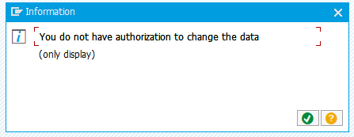
- Click on the print icon
- After the report regenerates, click on the Local File icon
- The file format should default to unconverted. Click on the green check.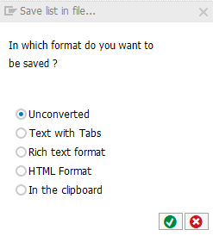
- Select a location and name for your file and click Generate. It is ok for the format to be a .txt file.
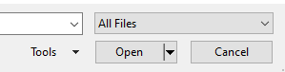
- Open Excel and open the file. You will need to change the file type to “All Files” to ensure that the file you saved is visible.
- In the Text Import Wizard step 1, select Delimited, then click Next
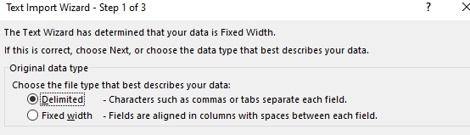
- For step 2, deselect Tab and then enter a | (pipe) in the “Other” field, then click Finish.
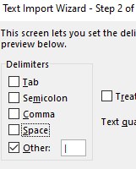
- The result is a list of fiscal approvers by business area and funds center.

